Should You Pastor a Church You Would Never Attend?

October 29, 2016 – Phil A. Newton

Questions about God’s will in accepting a pastoral call can dog pastors. Andrew Fuller, a noted 18th-century British pastor and theologian, spent three years struggling over whether to leave his pastorate in Soham to accept a call to Kettering. The decision to move led to one of that generation’s most memorable pastorates.
But not all turn out that way. Some moves leave pastors wondering if staying put would have proved better.
When considering a pastoral call, one often takes a sobering look at the new church: Do they believe the gospel? Will they appreciate expository preaching? Do they want biblical leadership? Are they interested in spiritual growth? Do they have a heart for discipleship? Will they adequately support my family?
Unfortunately, each of these questions won’t always be answered clearly before accepting a call. Rarely do initial visits and discussions give the full picture. In such cases, the newly installed pastor may face some rude awakenings. He may wonder if he’d even attend the church if they weren’t writing his paycheck.

Yes and No
So should you take a ministry position in a church you wouldn’t otherwise attend? Yes and no. To begin with, how often do ministers receive calls to healthy churches? Ministers in healthy churches are often there for the long haul. And in all likelihood, their church didn’t look nearly so healthy or inviting when they first stepped into the pulpit.
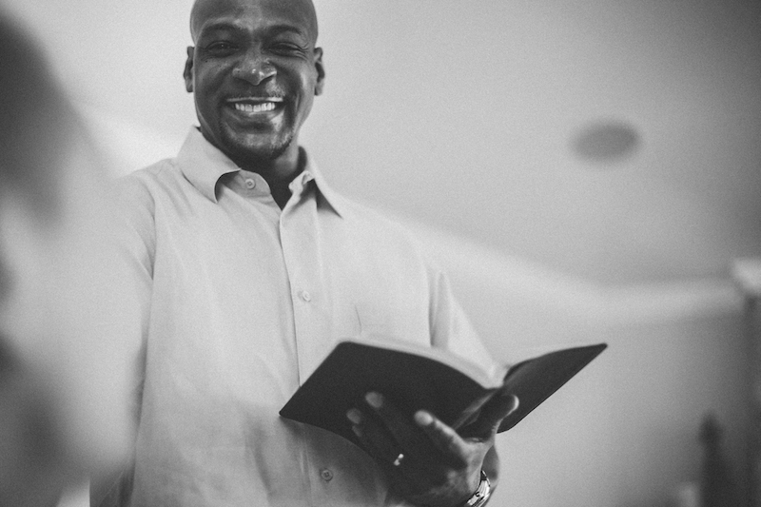
Prospective pastors face a similar challenge. At first glance, the church might appear uninviting. Quirky points, odd traditions, and dubious teaching abound. Other churches in the community seem more appealing. But might the Lord find pleasure in you embracing that charge as a means of shepherding them in the gospel, leading them in biblical church membership, and moving them toward gospel outreach? What are your reasons for accepting or declining the church’s call? Perhaps you are God’s choice instrument for them, perhaps not.
Here are five questions to consider:
1. Is my desire to accept or decline merely a concern for personal preference?
Maybe the prospective church doesn’t resemble your present church, so it’s off-putting. Or maybe you find the people objectionable due to their cultural leanings. Is personal rigidity a good companion in pastoral ministry?
2. Is there a substantive doctrinal matter that causes you to decline?
Do they reject the authority of Scripture or believe another gospel? If so, then decline. Or is the doctrinal issue simply due to poor shepherding? It might take seven to ten years or more to see the church become healthy. Can you commit that time to see it through? If not, then don’t go.
3. Is it simply a fear of difficulty that leaves you punting?
Running from hardship is never successful in the long run. Difficulties linger in ministry. But it could be that you lack the maturity and training at this point to accept this kind of pastoral charge. That’s nothing to be ashamed of. Discern your particular gifts and capacities in consultation with others who know you well. There are plenty of churches I wouldn’t want to tackle despite 40 years in pastoral ministry.
4. Is the congregation so untrained, immature, and unhealthy that you just can’t face the challenge?
Would the long-term investment in seeing the church to health have adverse effects on your wife and children? Then you might show more faithfulness by declining, instead of accepting their call and then abruptly leaving for personal sanity. Brief pastorates do little to improve a church’s health—or yours. It’s probably best for both you and the church to decline rather than to accept regrettably.
5. Are you expecting too much?
Do you look at healthy churches that took years to mature and think you have the right to inherit one? Pastoring is not a cakewalk. Weigh the costs, depend on the Lord, and make your decision accordingly.

One Man’s Example
In the mid-18th century, 24-year-old Robert Hall accepted the call to pastor a small Baptist church in Arnsby, England, comprising 26 “poor and plain people.” Although he felt unfit for such a charge, Hall gave himself to the work.
A power struggle ensued. Someone left the church an endowment under the control of a trustee who opposed Hall. For six years the trustee refused to allow Hall and the congregation to use the chapel or the manse. So they met in homes, often with jeering hecklers outside, as Hall faithfully preached Christ and shepherded the flock. Finally, they gained access to the chapel and the manse, where Hall would spend the rest of his life (39 years) in ministry.
But life was not easy. Hall supported his large family on £15 annually, plus what he could muster on farming 18 acres. His wife went through bouts of mental illness, leaving him as sole caretaker for his 14 children. Some of his Baptist colleagues remained steeped in High (hyper) Calvinism, criticizing Hall who stood firmly on the free offer of the gospel. For the whole of his life, Hall pastored a small church in an obscure village with a meager income.
Yet no one had more influence on the key figures of the modern missions movement than Hall did. A young William Carey sometimes walked 20 miles to hear him preach and to seek his counsel. Hall mentored Fuller, preached his pastoral installation sermon at Kettering, and shaped his theology. John Ryland Jr. considered Hall and John Newton as his chief mentors. Hall’s son, Robert Jr., who had an astonishing ministry in Cambridge, learned theology and ministry at his father’s side.

Discern and Decide
Would Robert Hall have otherwise attended the church at Arnsby? That’s a question we can’t answer. Yet I think we can confidently say that at the end of his life, despite years of struggles and difficulties, he didn’t regret pastoring it. His obscure ministry turned out not so obscure with its breadth of global influence.
Should you accept a call from a church you wouldn’t attend? That’s where discernment and humility, along with wise counsel and a willingness to follow Christ, will give you clarity.

This article was originally published on The Gospel Coalition website and is used with permission. The original can be found here: https://www.thegospelcoalition.org/article/should-you-pastor-a-church-you-would-never-attend/.

